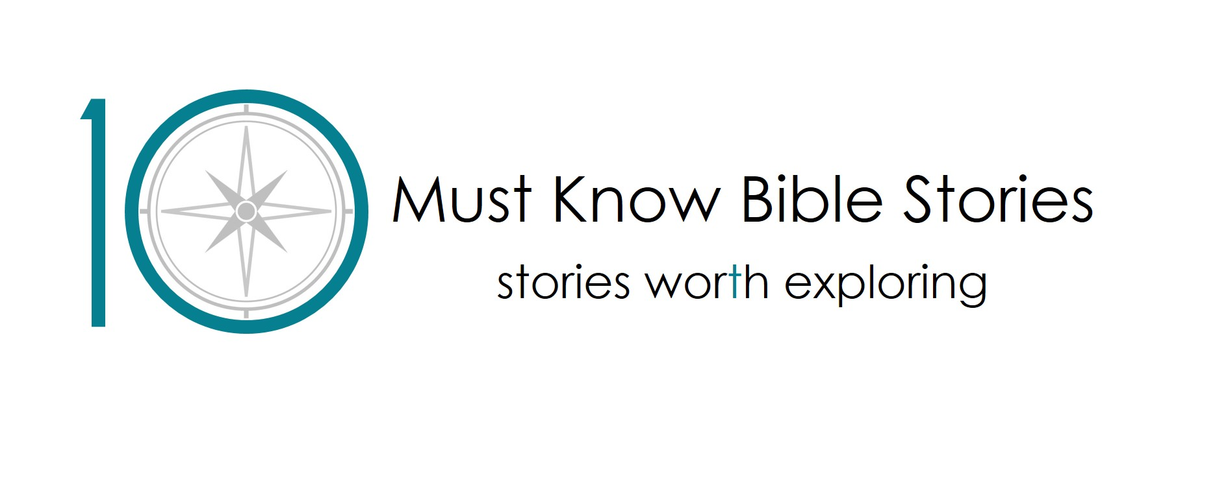

Do you ever feel unsafe or afraid?
Noah’s Ark

ASSEMBLY: Do you ever feel unsafe or afraid?

HWB link: There are lots of situations where we feel unsafe or afraid. Remembering we don’t need to go through them alone can help.
Key learning: As we hear the story of Noah’s Ark we will learn that God was always there helping Noah when he felt unsafe and afraid. Christians believe that God is always with them and when they feel unsafe or afraid they can talk to him.
Content: Conversation around times we feel unsafe or afraid, a quiz on floating and sinking, the story of Noah’s ark told in the bath and a brief description of Christian belief.
Challenge issued: Create a rainbow outside.
Next steps:
- Help your class complete the challenge.
- Watch the first filmed mini lesson appropriate for your lesson.
OR
- Mix and match from the filmed mini lessons and our standard resources. Access our standard resources, full lesson plans based around the story of Noah’s Ark from 10 Must Know Bible Stories here https://tenbiblestories.org/resources/noahs-ark/. These are free to download and all resources you need are provided to download.

EARLY YEARS

Mini-lesson 1:

Key learning: Christians believe that when we trust in God he keeps us safe.
Content: We’ll have a picture quiz to think about staying safe, will join in the story with actions, listen to a brief discussion around the key learning point and take part in a fun quiz on the story. The children are challenged to create a boat that will float.
Prior learning required before watching:
- Children must have heard the story of Noah’s Ark. Either watch “Do you feel unsafe or afraid” assembly as described above or watch an animated version of the story. https://www.youtube.com/watch?v=4yzN0fUxjkQ
Preparation required before watching: be ready to pause the video to take answers for the picture quiz and to support them during the story quiz. Decide how you will facilitate them to take on the challenge.
Next steps:
- Help your class complete the challenge.
- Why not extend their learning by talking about who keeps them safe. They could make a thank you card for that person.
- Watch mini lesson 2.

Mini-lesson 2:

Key learning: Christians believe that God keeps his promises.
Content: We’ll play pictionnary to remind us of the story of Noah’s Ark before focussing on the rainbow and God’s promise. We’ll think about what a promise is and why it’s important to Christians to know that God keeps his promises. The children are challenged to go on a rainbow hunt.
Prior learning required before watching: Children must have heard the Biblical story of Noah’s Ark and ideally watched and enjoyed Mini-lesson 1 as described above.
Preparation required before watching: Be ready to pause the video in the game of pictionnary to take answers and to discuss what the children think a promise is.
Next steps:
- Complete the challenge to go on a rainbow hunt outside. Try to find something from each colour of the rainbow.

FIRST LEVEL

Mini-lesson 1:

Key learning: Christians believe that when we trust in God he keeps us safe.
Content: A picture quiz,an opportunity to join in the story with actions, a brief discussion around the key learning point and a fun quiz on the story. The children are challenged to create a boat that will float.
Prior learning required before watching:
- Children must have heard the story of Noah’s Ark. Either watch “Do you feel unsafe or afraid” assembly as described above or watch an animated version of the story. https://www.youtube.com/watch?v=4yzN0fUxjkQ
Preparation required before watching:
- Be ready to pause the video to take answers for the picture quiz and to support them during the story quiz.
- Decide how you will facilitate them to take on the challenge.
Next steps:
- Complete the challenge set in the video.
- Extend their learning by enjoying the activities found in lesson 3 from our Noah’s Ark first level resources. Download them here https://tenbiblestories.org/resources/noahs-ark/
- Watch mini lesson 2.

Mini-lesson 2:

Key learning: Christians believe that God keeps his promises.
Content: We’ll play pictionnary to remind us of the story of Noah’s Ark before focussing on the rainbow and God’s promise. We’ll think about what a promise is and why it’s important to Christians to know that God keeps his promises. The children are challenged to go on a rainbow hunt.
Prior learning required before watching:
- Children must have heard the Biblical story of Noah’s Ark and ideally watched and enjoyed Mini-lesson 1 as described above.
Preparation required before watching:
- Be ready to pause the video in the game of pictionnary to take answers and to discuss what the children think a promise is.
Next steps:
- Complete the challenge set in the video.
- Extend their learning by enjoying the activities found in lesson 4 from our Noah’s Ark first level resources. Download them here https://tenbiblestories.org/resources/noahs-ark/

SECOND LEVEL

Mini-lesson 1:

Key learning: Christians believe when we trust in God he keeps us safe.
Content: We’ll start with a quiz to remind ourselves of the story before considering what we think the most important part of the story is. We’ll be asked to pause the video and create that part. We’ll consider Noah’s obedience and trust in God which will help us briefly explore the Christian belief that If we trust in God he will keep us safe. The children will be challenged to write down as many questions around the story as they can.
Prior learning required before watching:
- Children must have heard the Biblical story of Noah’s ark. Either watch “Do you ever feel unsafe or afraid” Assembly as described above, watch an animation of the story or read it yourselves in the Bible/Children’s Bible.
Preparation required before watching:
- Be ready to support the children during the quiz.
- Decide beforehand how the children will create what they think is the most important part of the story.
Next steps:
- Complete the challenge as suggested in the video.
- Extend the learning by enjoying the activities found in lesson 2 from our Noah’s Ark second level resources. Download them here https://tenbiblestories.org/resources/noahs-ark/
- Watch mini lesson 2.

Mini-lesson 2:

Key learning: Christians believe God makes and keeps promises.
Content: We’ll start with a few rounds of Kim’s game to remind ourselves of the story before considering the symbol of the rainbow associated with God’s promise. We’ll remind ourselves what a promise is and rank promises on an easy to keep - hard to keep scale. We’ll consider the Christian belief that God never breaks a promise and how that makes a difference to Christians. The class are issued a challenge to find another promise God makes in the Bible.
Prior learning required before watching:
- Children must have heard the Biblical story of Noah’s Ark and ideally watched Mini-lesson 1 as described above.
Preparation required before watching:
- You will need to be ready to support the children in the game and the ‘easy to keep/hard to keep’ activity.
- You’ll need to be ready to pause the video for discussions.
Next steps:
- Complete the challenge as suggested in the video.
- Extend the learning by enjoying the activities found in lesson 3 from our Noah’s Ark second level resources. Download them here https://tenbiblestories.org/resources/noahs-ark/

