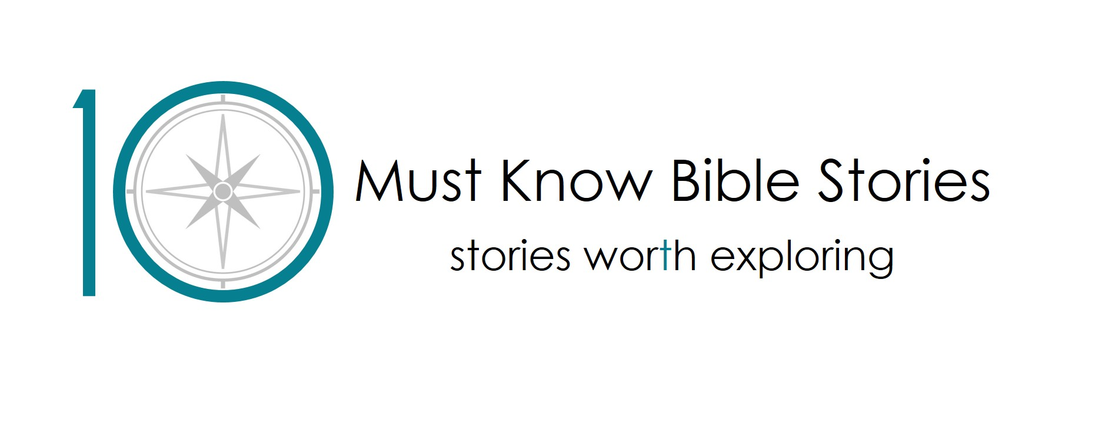
We love being outdoors! I wonder why?
The Creation Story.

ASSEMBLY: We love being outdoors! I wonder why?

HWB link: It’s good to be outside. It is good for our physical, emotional, mental and spiritual health.
Key learning: As we consider why it’s good to be outside, children will learn that Christians believe that God made the world and one reason we enjoy being outside is because we’re part of God’s creation. Christians believe that part of our enjoyment of being outside is linked to a connection with the creation and the creator.
Content: We will consider together why it’s good to be outside, briefly touching on the science behind this. We will hear the story of creation explained and take part in a photo quiz.
Challenge issued: Create a picture of your favourite outdoor place using only natural objects.
Next steps:
- Help your class complete the challenge.
- Watch the 1st filmed mini lesson appropriate for your level.
OR
- Mix and match from the filmed mini lessons and our standard resources. Access our standard resources, full lesson plans based around the story of Creation from 10 Must Know Bible Stories here https://tenbiblestories.org/resources/creation/. These are free to download and all resources you need are provided to download.

EARLY YEARS

Mini-lesson 1:

Key learning: Christians believe that our wonderful world tells us that the God who made it is wonderful too!
Content: A quiz for us to join in with as we recap the Creation story. We’ll hear a verse from the Bible where the writer tells us the wonderful skies he sees reminds him of how wonderful God is. We’ll have a picture quiz looking at different sky pictures. We leave the children with a challenge to find 3 natural objects; something soft, something smooth and something tiny.
Prior learning required before watching:
- Children must have heard the story of creation. Either watch “We love being outdoors! I wonder why? Assembly” as described above or watch an animated version of the story such as:
https://www.youtube.com/watch?v=_PBpCA2nxG8 (stop at 2 min 11s)
or
https://www.youtube.com/watch?v=teu7BCZTgDs
Preparation required before watching: none needed.
Next steps:
- Help your class complete the challenge set in the video.
- Why not extend their learning by encouraging them to make a picture of something God made using natural objects, creating a cosy place to rest and recap the rhyme taught in the mini-lesson film.
- Watch mini-lesson 2

Mini-lesson 2:

Key learning: Christians believe that God made people special.
Content: We’ll watch objects as they’re taken out of a story bag to remind us of the story of God making the world. We’ll spot which of our friends have a particular hair colour or eye color. We’ll join in actions to a song. We leave the children with a challenge to draw or make a picture of their face today encouraging them to remember that Christians believe God made them and thinks they are great!
Prior learning required before watching:
- Children must have heard the Biblical story of creation and ideally watched and enjoyed Mini-lesson 1 as described above.
Preparation required before watching:
- Remind children they can’t sing, but just join in with the actions. (if that is currently the rule)
Next steps:
- Help the children complete the challenge to draw or make their face as set in the video.
- Why not play a parachute game; invite the children to run underneath if they have brown hair/blue eyes/wearing something red etc.

FIRST LEVEL

Mini-lesson 1:

Key learning: Christians believe that our wonderful world tells us that the God who made it is wonderful too!
Content: A quiz for us to join in with as we recap the Creation story. We’ll hear a verse from the Bible where the writer tells us the wonderful skies he sees reminds him of how wonderful God is. We’ll have a picture quiz looking at different sky pictures. We leave the children with a challenge to find 3 natural objects; something soft, something smooth and something tiny.
Prior learning required before watching:
- Children must have heard the story of creation. Either watch “We love being outdoors! I wonder why? Assembly for P1-3” as described above or watch an animated version of the story.
https://www.youtube.com/watch?v=_PBpCA2nxG8 (stop at 2 min 11s)
or
https://www.youtube.com/watch?v=teu7BCZTgDs

Preparation required before watching: none needed.
Next steps:
- Help the children complete the challenge to draw or make their face as set in the video.
- Enjoy the activities and learning described in lesson 2 from our Creation first level resources. Download them here https://tenbiblestories.org/resources/creation/
- Watch mini lesson 2

Mini-lesson 2:

Key learning: Christians believe that God gave people the job of looking after the world.
Content: We’ll play Kim’s game to help us remember the Bible story. We’ll hear that the Bible tells us that God gave people the job of looking after the world and then consider together if we think we’re doing a good job of it. We’ll pause to wonder why we think God asked people to look after the world. We’ll leave you with a challenge to decide on a way they can look after the world and go and do it!
Prior learning required before watching:
Children must have heard the Biblical story of creation and ideally watched and enjoyed Mini-lesson 1 as described above.
Preparation required before watching:
- Watch the video before you show it to your class so you’re prepared to accept children’s answers at various points.
- You may want to pause the video during the “on a scale of ..” activity to comment on who selected what point on the scale and you may want to pause the video to hear the children’s responses to the question ‘why do you think God asked people to look after the world?’
- The class are issued a challenge to decide on a way they can look after a part of the world. Again, after watching the video you may wish to have a few ideas ready to suggest to the class.
Next steps:
- Help the children complete the challenge as suggested in the video.
- Extend the learning by enjoying the activities found in lesson 3 from our Creation first level resources. Download them here https://tenbiblestories.org/resources/creation/

SECOND LEVEL

Mini-lesson 1:

Key learning: Christians believe the world is evidence of God’s existence. They believe he made it simply by speaking. Christians believe God resting on the 7th day teaches us that we should build rest into our lives.
Content: There is discussion around the Christian belief above interspersed with a quiz on fascinating facts about our world and a charades game about ways to rest. The class are issued a challenge to find a natural object that amazes them and find out about it.
Prior learning required before watching:
- Children must have heard the Biblical story of creation. Either watch “We love being outdoors! I wonder why? Assembly”, watch an animation of the story (https://www.youtube.com/watch?v=teu7BCZTgDs) or read it yourselves in the Bible/Children’s Bible.
Preparation required before watching:
- Be ready to accept answers for the quiz and the charades game. You might want to pause the video during this.
Next steps:
- Complete the challenge as suggested in the video.
- Extend the learning by enjoying the activities found in lesson 4 from our Creation second level resources. Download them here https://tenbiblestories.org/resources/creation/
- Watch mini lesson 2.

Mini-lesson 2:

Key learning: Christians believe God gives them the responsibility to care for the world.
Content: We’ll start with a quiz to reinforce our key learning. The above belief is then explored with a discussion activity. The class are issued a challenge to choose one aspect of creation and come up with 5 ways they can look after it.
Prior learning required before watching:
- Children must have heard the Biblical story of creation and watched Mini-lesson 1 as described above.
Preparation required before watching:
- You will need to be ready to support the children in the quiz and the discussion activity. Whiteboards and markers will be useful if you want to ask the children to respond to the questions individually and then get them to share their answers. You will need to pause the video to allow for this discussion.
Next steps:
- Complete the challenge as suggested in the video.
- Extend the learning by enjoying the activities found in lesson 3 from our Creation second level resources. Download them here https://tenbiblestories.org/resources/creation

